1. **Touch Screen:**

There are two options to connect the 15.6 inch touch screen to Raspberry Pi.

* 1. Using DSI (Display Serial Interface)
  2. Using micro HDMI

1. **Two Camera:**

You can connect one camera to the Camera port in the Raspberry Pi as shown.

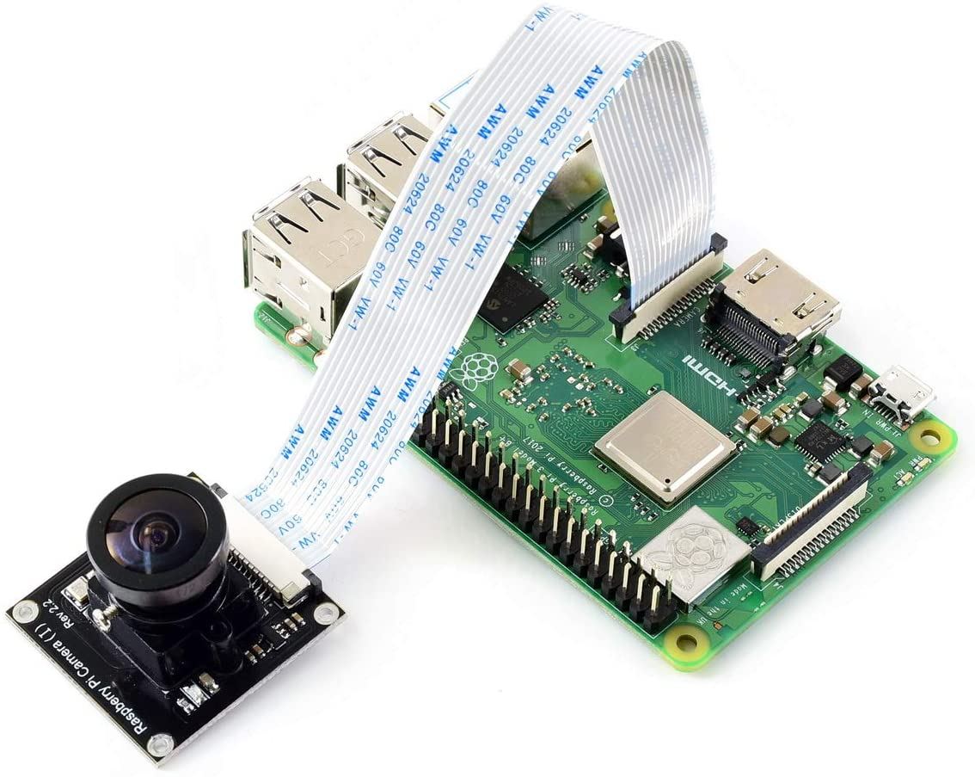

Camera Buy Link: <https://www.amazon.com/Waveshare-RPi-Camera-Raspberry-640480p60/dp/B01AD5ZN3U>

<https://www.adafruit.com/product/3099>

You can use a USB camera as second camera.

Link: <https://www.amazon.com/Ximimark-Camera-Raspberry-Require-Drivers/dp/B07GWP2SGV>

1. **Speaker and Mic:**

We have three options here:

* 1. First option is to use a USB sound card in order to separately connect mic and speaker.

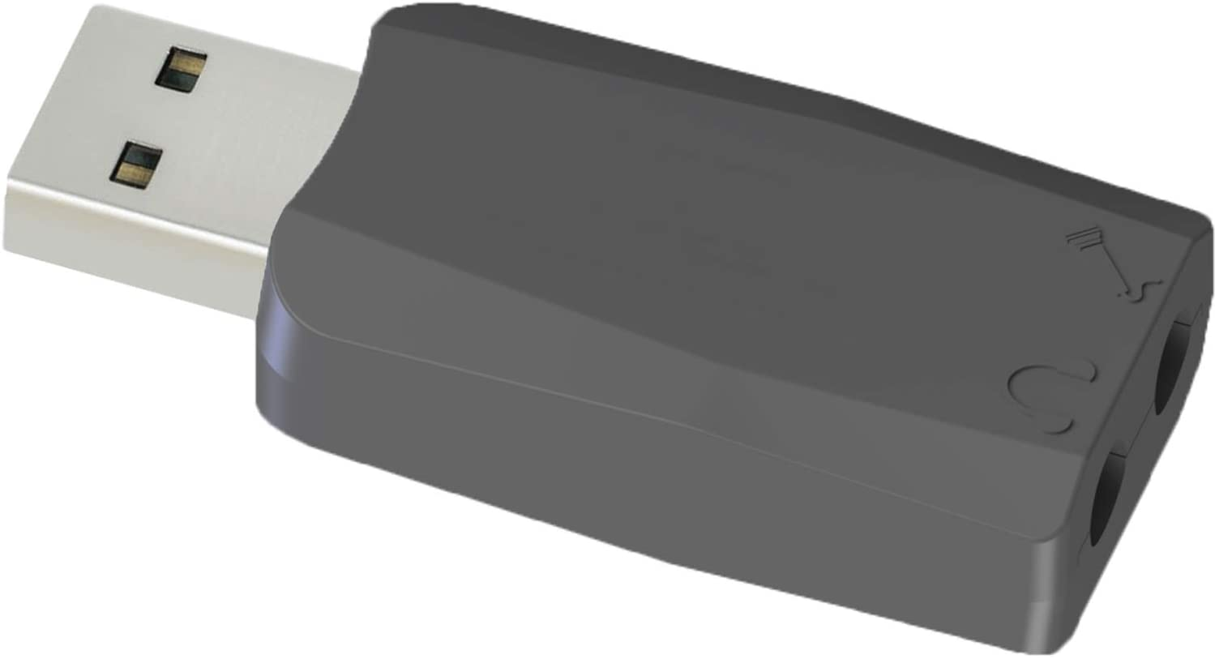

This will enable you to connect both speaker and mic separately using audio jacks.

Link: <https://www.amazon.com/External-Windows-Raspberry-Headphones-Microphones/dp/B07DBNFZJR/ref=sr_1_10?dchild=1&keywords=usb+microphone+raspberry+pi&qid=1617162834&refresh=1&sr=8-10>

* 1. The second option is to use a USB microphone and a normal audio jack speaker.

Link: <https://www.amazon.com/Microphone-Condenser-Omnidirectional-Recording-Streaming/dp/B08DMRHNK7/ref=sr_1_9?dchild=1&keywords=usb+microphone+raspberry+pi&qid=1617297697&sr=8-9>

* 1. The third option is to get a simple mic and a speaker, make a small circuit for it like in our headphones and it will have a combo audio jack which will directly go to the audio jack of the raspberry pi.

We have another option of using a microphone raspberry pi hat for microphone and speaker.

Link: <https://www.seeedstudio.com/ReSpeaker-4-Mic-Linear-Array-Kit-for-Raspberry-Pi.html>

1. **Bluetooth and WiFi:**  Bluetooth 5.0 and WiFi 5Ghz and 2.4 GHz are built-in in Raspberry Pi 4.
2. **NFC:** You can use this NFC Hat for Raspberry Pi. But you will have to write a program for it.

**URL:** <https://www.waveshare.com/pn532-nfc-hat.htm>

1. **Microwave sensor chip:**

You can use this sensor with Raspbery Pi. You will have to program it according the following circuit.

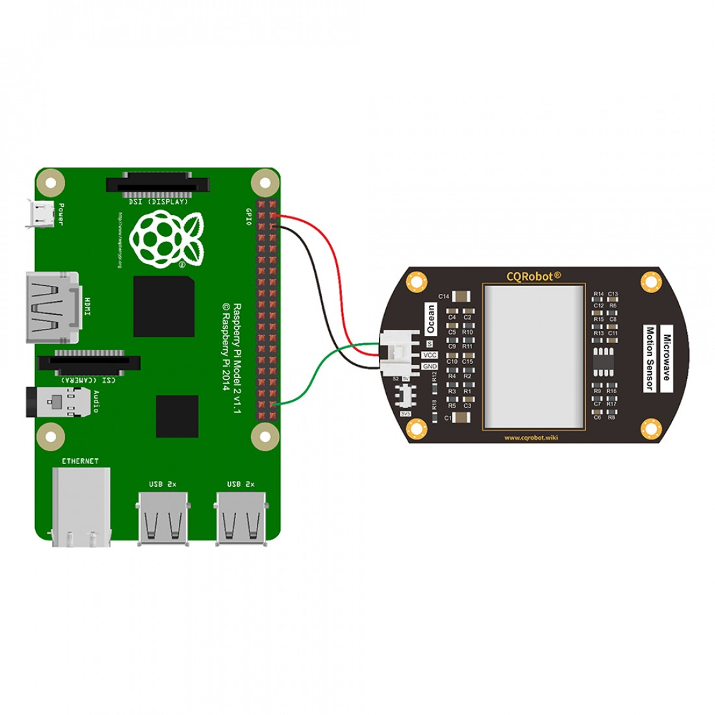

You can get this from this link.

**URL:** <https://www.cqrobot.com/index.php?route=product/product&product_id=1135>

You can also use PIR Motion Sensor:

<https://www.amazon.co.uk/DIYmall-HC-SR501-Motion-Infrared-Arduino/dp/B012ZZ4LPM/ref=sr_1_5?dchild=1&keywords=pir+sensor+arduino&qid=1617300336&sr=8-5>

Tutorial to use PIR Motion Sensor with Raspberry Pi

<https://maker.pro/raspberry-pi/tutorial/how-to-interface-a-pir-motion-sensor-with-raspberry-pi-gpio>

1. **433 Mhz chip:**

You can use this with raspberry pi.

**URL:** <https://www.amazon.com/Transmitter-Receiver-Arduino-Raspberry-Wireless/dp/B07PDGKW8B>

For transmitting you can use a microcontroller. For example; Arduino Nano or Arduino UNO.

This is a tutorial about transmitting and receiving data using 433MHz chip with Arduino. But you will use only the transmitter code and circuit. For Receiving using Raspberry Pi you will have to connect it to raspberry Pi and program it.

<https://randomnerdtutorials.com/rf-433mhz-transmitter-receiver-module-with-arduino/>

Here are the links for Arduino UNO and Arduino Nano:

<https://www.amazon.com/Arduino-A000066-ARDUINO-UNO-R3/dp/B008GRTSV6>

<https://www.amazon.co.uk/Arduino-A000005-ARDUINO-NANO/dp/B0097AU5OU>